LAB ASSIGNMENT A3.1

Lines
Background:

If a point can be represented as a coordinate (x, y), then a line can be defined by a set of 2 points (x1, y1) and (x2, y2). This definition makes it easy to draw the line using popular graphics libraries (such as processing) or do math involving the line.

For example, it is not too difficult to figure out if two lines intersect each other. If our lines are defined by sets of points like this:
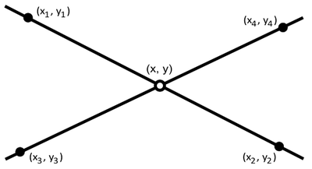

Then the intersection point of the lines can be found using the following equation:
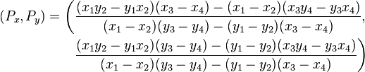

It’s important to note, of course, that parallel lines do not intersect. In the case that the two lines are parallel, the bottom term in the divisions above would be zero (and it’s very inadvisable to divide by zero).

This equation gives the intersection point of continuous, forever expanding lines, not line segments. To know whether just specific segments of lines intersect, find the intersection point, then check to see if the x-coordinate of the point falls in between the x-coordinates of the two lines (and similarly for the y-coordinate).

Assignment:

- Download the tester classes from SchoolLoop. Add them to a new project called Lines.
- The tester uses a class called Line (which does not yet exist). Create this new class!
- You can add any fields, constructors, or methods that are fitting for a Line class. However, you must add structures with the following headers:

// Constructs a line from (x1, y1) to (x2, y2)
public Line(double x1, double y1, double x2, double y2)

// Sets this line’s second point (x2, y2) to a new coordinate
public void setPoint2(double x2, double y2)

// Draws this line using the PApplet passed as an argument
public void draw(PApplet drawer)

// Returns true if this line segment and the segment other intersect each other. Returns false if they do not intersect.
public boolean intersects(Line other)

BONUS
Update the Line class and the tester so that a dot is drawn at the point of intersection between the two lines.

